# Instructions – Exercise 5.3 – Data Tables

**Layout**

book-list

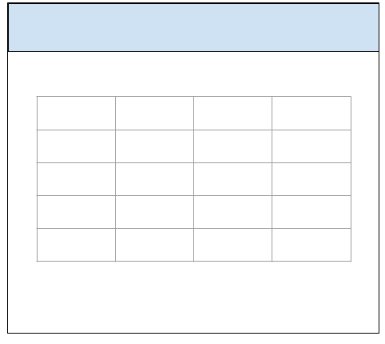

in-n-out-books, part 2

**Instructions**

* ~~Make a copy of the in-n-out-booksp1 from Exercise 5.2 and add it to your week-5 directory~~
* ~~Rename the application to in-n-out-booksp2~~
* ~~Delete the node_modules directory~~
* ~~Delete the package-lock.json file~~
* ~~Open the angular.json file and find and replace all “in-n-out-booksp1” entries with “in-n-out-booksp2”~~
* ~~Open the package.json file and change the name to “in-n-out-booksp2”~~
* ~~Run npm install and ng serve~~
  + ~~You are doing this to test the application and confirm there are no errors~~
* ~~app.component.html~~
  + ~~Change the assignment name to “Exercise 5.3 - Data Tables”~~
* ~~app.module.ts~~
  + ~~Add an import statement for MatTableModule~~
    - ~~import { MatTableModule } from ‘@angular/material/table’;~~
  + ~~Add the MatTableModule to the imports array~~
* ~~Generate a new Angular service and name it books~~
  + ~~ng g s books~~
* ~~books.service.ts~~
  + ~~Import the IBook interface~~
    - ~~Import { IBook } from ‘./book.interface’;~~
  + ~~Import the Observable class from rxjs~~
    - ~~import { Observable } form ‘rxjs’;~~
  + ~~Import the of operator from rxjs~~
    - ~~import { of } from ‘rxjs’;~~
  + ~~Import the map operator from rxjs~~
    - ~~import { map } from ‘rxjs/operators’;~~
  + ~~Add a books variable of type Observable<IBook>~~
    - ~~books: Array<IBook>~~
  + ~~In the services constructor, create 5 new book objects and prefill them with your favorite books.~~
  + ~~Create two new functions: getBooks() and getBook(isbn: string)~~
  + ~~getBooks()~~
    - ~~Set the return type to an Observable Array of IBook objects~~
      * ~~getBooks(): Observable<IBook[]>~~
    - ~~Cast the books array to an observable and return them~~
  + ~~getBook(isbn)~~
    - ~~Set the return type to IBook~~
      * ~~getBook(isbn: string): IBook~~
    - ~~Loop over the array of books and return a book matching the passed-in isbn number~~
* book-list.component.ts
  + ~~Add an import statement for the BooksService~~
    - ~~import { BooksService } from ‘../books.service’;~~
  + ~~Add an import statement for IBook interface~~
    - ~~import { IBook } from ‘../book.interface’;~~
  + ~~Add an import statement for Observable~~
    - ~~import { Observable } from ‘rxjs’;~~
  + ~~Create a books variable of type Observable<IBook[]>~~
  + ~~Add the BooksService to the components constructor~~
    - ~~constructor(private booksService: BooksService)~~
  + ~~In the components constructor call the booksService.getBooks() function and assign the results to the books variable~~
  + ~~Create a variable named header of type Array<string> and assign it the following values:~~
    - ~~Isbn, title, numOfPages, authors~~
  + ~~Create a variable named book of type IBook~~
  + ~~Create a function called showBookDetails(isbn: string)~~
    - ~~In the body of the showBookDetails(isbn: string) function make a call to the booksService.getBook(isbn: string) and map the return object to the book variable~~
    - ~~console.log() the book object (we are doing this to test that the service is returning the correct book object)~~
* ~~Book-list.component.html~~
  + ~~Create a Flex row div and wrap the content~~
    - ~~Using the header and books as data sources, create an Angular data table~~
    - ~~Give the data table a header <h2> and title of “Top 5 Favorite Books” and a font color of green~~
    - ~~Using JavaScripts built-in join() function, join the authors array into a comma delimited string~~
      * ~~{{ element.authors.join(‘, ‘)  }}~~
  + ~~Wrap the isbn row with an anchor tag and Angular’s click directive with a call to the showBooksDetails(isbn: string) function~~
    - ~~Add CSS styling for text-decoration: none; color: blue~~
    - ~~Add CSS styling for hover cursor: pointer; text-decoration: underline~~